**What Kind of Problem is This?**

We have learned to make inferences about four parameters:

p, µ, p1- p2, µ1-µ2. So now at the end of the course how do we tell which of these we have in a particular question? When you read a question ask yourself two questions:

1) Is the question about the mean of a quantitative variable, or is it about the proportion of a group that have a certain trait (categorical)?

2) Is the question about one population or is it comparing two populations?

The sketch below shows how to decide which type of problem we have.

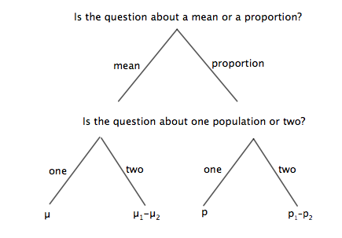

We have learned to use two statistical methods: confidence interval and hypothesis test.

The formulas are:

Confidence interval: ± multiplier*SE + center

Hypothesis test: test statistic = 

You will be given the following table of formulas:

|  |  |  |
| --- | --- | --- |
| Parameter | sample estimate | Standard error |
| µ |  |  |
| p |  |  |
|  |  |  |
|  |  |  |

In each of the problem situations below, do the following:

A) Identify problem type: mean or proportion? one population or two?

Confidence Interval or Hypothesis Test?

B) Write a sentence defining the parameter (include its symbol; no numbers; not sample)

C) Write the symbol for the sample estimate and the formula for the SE of the sample estimate.

D) Complete the necessary calculations to answer the question.

1. **Fritos**. As a project for an introductory statistics course, students checked 6 bags of Fritos marked with a net weight of 35.4 grams. They carefully weighed the contents of each bag, recording the following weights (in grams): 35.5, 35.3, 35.1, 36.4, 35.4, 35.5.

a) Define the population parameter in this context.

b) Do these data satisfy the necessary conditions? Explain.

c) Make a 95% confidence interval and write a sentence interpreting it.

d) What would you conclude about the stated net weight?

2. **Computer use**. A Gallup telephone poll of 1240 teens conducted in 2001 found that boys were more likely than girls to play computer games, by 77% compared to 65% for girls. An equal number of boys and girls were surveyed. Give a 95% confidence interval for the difference in game playing by gender.

3. **Shipping time.** An internet company claims that 90% of its orders are shipped within two days. Suppose that last month they received 4000 orders. A consumer group questioning the claim took a random sample of 200 orders and found that 168 were shipped within 2 days. Is this strong enough evidence to conclude that less than 90% of all orders received were shipped within two days? Use a significance level of 5%.

4 **Teach for America**. Several programs attempt to address the shortage of qualified teachers by placing uncertified instructors in schools with acute needs—often inner cities. A 1999–2000 study compared students taught by certified teachers with others taught by under certified teachers in the same schools. Reading scores of the students of certified teachers averaged 35.62 points with standard deviation 9.31. The scores of students instructed by under certified teachers had mean 32.48 points with standard deviation 9.43 points on the same test. There were 44 students in each group. The appropriate t procedure has 86 degrees of freedom. Is there evidence of lower scores with uncertified teachers? Discuss.

Multiple Choice:

